11-E-01405 SOW 2 - Rear and Trailer Camera Description of test environment

Version: | 0.1.3
Last modified: | 20-Oct-2025
Status: | draft

Version history:
Version: | Implemented By: | Revision Date: | Changes:
0.1 | Völler J. | 09-Sep-2025 | Document created
0.1.1 | Völler J. | 10-Oct-2025 | Overview of environment added
0.1.2 | Völler J. | 13-Oct-2025 | Device descriptions added
0.1.3 | Völler J. | 20-Oct-2025 | Device descriptions added

Table of Contents
1 Introduction 4
1.1 PURPOSE OF THE DOCUMENT 4
1.2 SCOPE 4
1.3 REFERENCES 4
1.4 CLOSSARY 4
2 DETAILED TEST ENVIROMENT REQUIERMENTS 5
2.1 Overview 5
2.2 POWER SUPPLY 6
2.3 Digital Multimeter 7
2.4 Logic Analyzer 8
2.5 Automotive Ethernet Switch 8
2.6 Automotive Ethernet Converter 9
2.7 Temperature testing chamber 10
2.8 HIL-PC 11
2.9 Test Environment Software 11
3 LIST OF FIGURES 12
4 LIST OF TABLES 13

- Introduction
  - PURPOSE OF THE DOCUMENT
The Description of test environment documents the necessary information required to implement the test environment for the camera platform system within the project 11-E-01405 SOW 2 - Rear and Trailer. The document covers the test environment for system integration tests and system tests.
The document is created during the development phase of the project. Its intended audience is the developer of the test environment and test team. Some portions of this document may on occasion be shared with the client / user and other stakeholders whose input / approval are needed.
  - SCOPE
This document defines the test environment of the project 11-E-01405 SOW 2 - Rear and Trailer, which shall be used for executing system integration tests as well as system tests. Furthermore, the hardware components to be used are defined. Besides that, the required functionalities of the test environment software are specified.
This document does not cover the test environments needed for any other test level of the 11-E-01405 SOW 2 - Rear and Trailer project. For a more detailed description of test levels and strategies as well as devices under test and features to be tested, see Test plan
  - REFERENCES
If not stated otherwise, always the latest version of the document is valid.
Document: | Path: | Description:
Test plan | Link | Description of test levels and strategies
Table 1: Referenced documents
  - CLOSSARY
Term: | Description:
GUI | Graphical user interface
Table 2: Glossary

- DETAILED TEST ENVIROMENT REQUIERMENTS
  - Overview
In the following section, the test environment items to be used are identified. These items are required to build up the test environment. With the test environment it shall be possible to implement (automate) and execute specified test cases. Furthermore, the generation of test reports is required as well as the possibility to manually execute tests. Table 3 gives an overview.

Item / component: | Description:
Power supply HIL: Rohde & Schwarz NGP824 | Max. 10A, arbitrary waveform, current and voltage measurement
Digital multimeter HIL: Siglent SDM3065X | Current and voltage measurement
Saleae Logic Pro 16 Logicanalyzer | Signal, I2C and SPI protocol analyzer
Technica Engineering  Enhanced Ethernet Switch MACsec H-MTD | Automotive Ethernet Switch
Technica Engineering  MediaConverter 100/1000BASE-T1 H-MTD TC10 | Automotive Ethernet Converter
Temperature test chamber Vötsch VT7004 | Temperature testing chamber for testing Heating feature
PC-HIL:  Lenovo ThinkStation P7 | Controlling all components, executing tests
Test environment software | Test implementation, execution and report
Table 3: Test environment items
The test environment consists of the components as listed in Table 3 and shown in Figure 1. A PC controls all the components of the test environment over a serial or network connection.
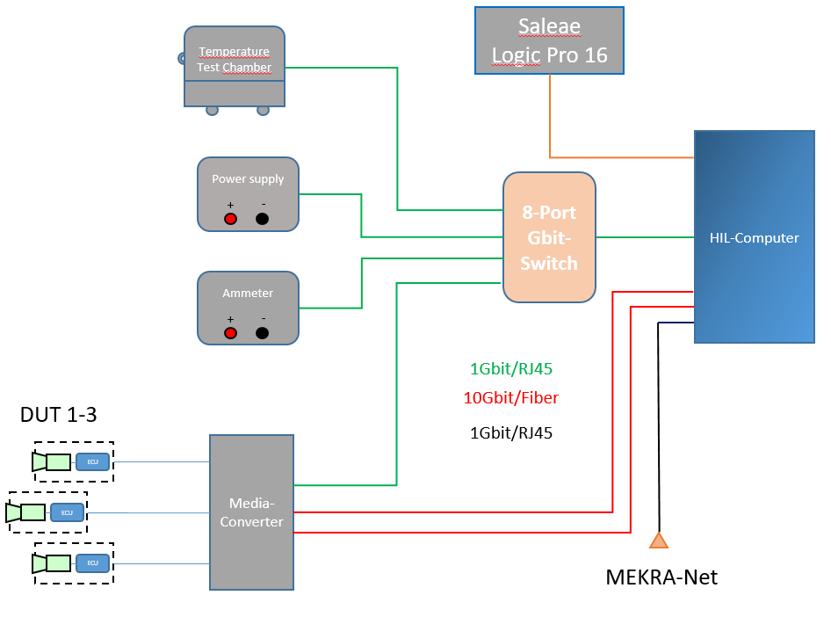
Figure 1: Test environment architecture for system test, system integration test and allocation test
  - POWER SUPPLY
Description:
Type: Rohde & Schwarz NGP 824 (ML03573)
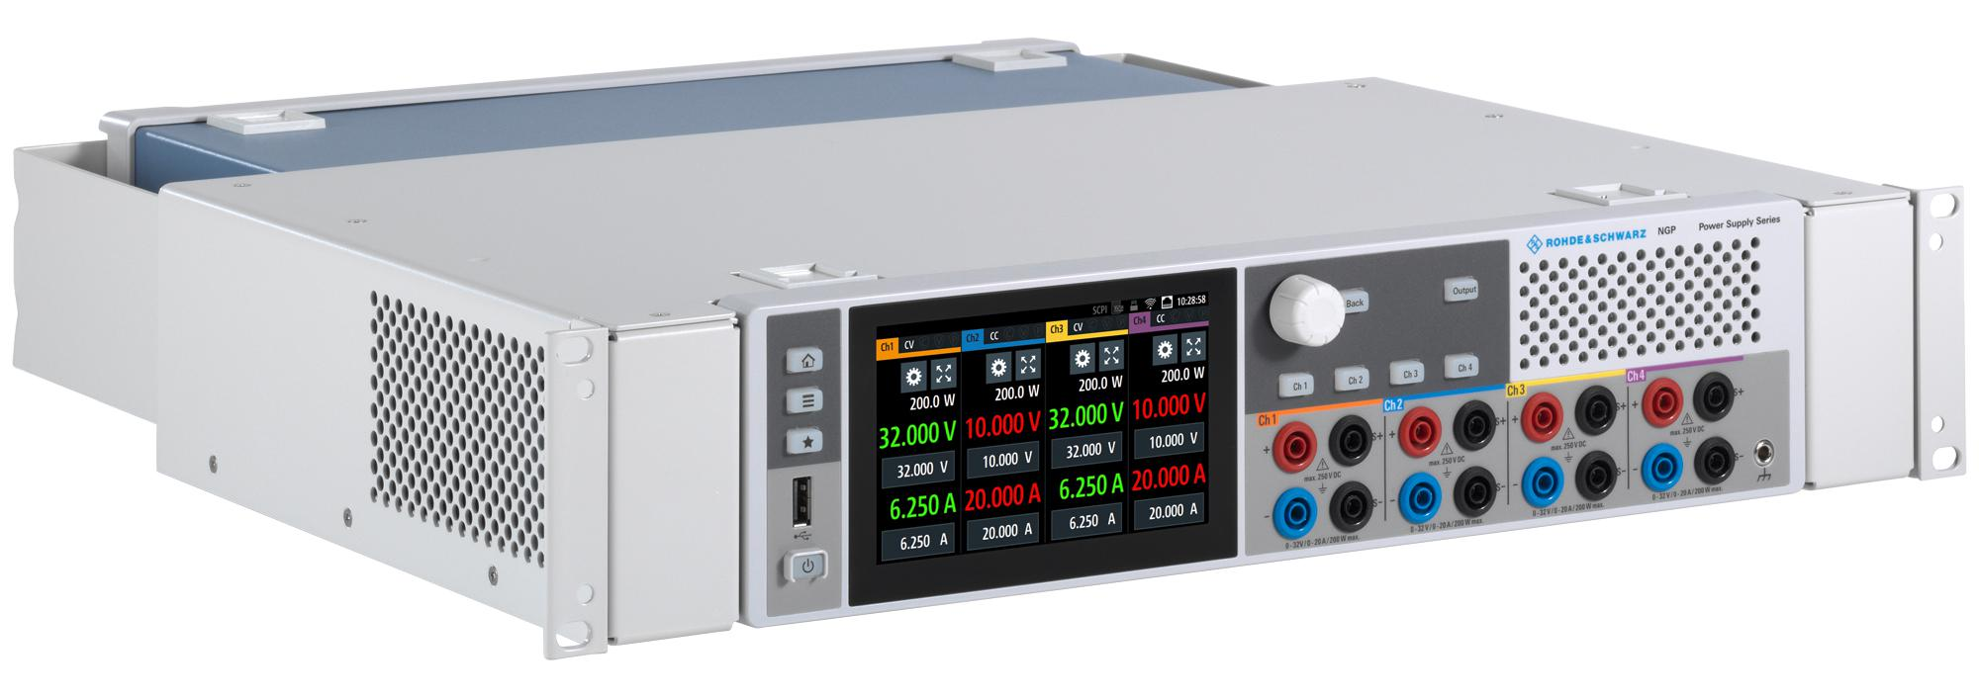
Figure 2: Rohde & Schwarz NGP 824 (ML03573)
- Supply voltage range: 0–64V
- Current range: 0–10A
- Power: 400W
- Remote control
- Arbitrary function:
  - 1024 interpolation points
  - 8 subgroups
  - 8 blocks with repeat function
  - 1ms–60s step time, resolution 1ms
  - continuous or burst mode with 1 to 65 535 repetitions
- integrated digital Multimeter
  - Measuring variables:
    - DC voltage
    - DC current
    - Power
    - energy
  - Data logging
  - Digital Multimeter
Description:
Type: Siglent SDM 3065X (ML03532)
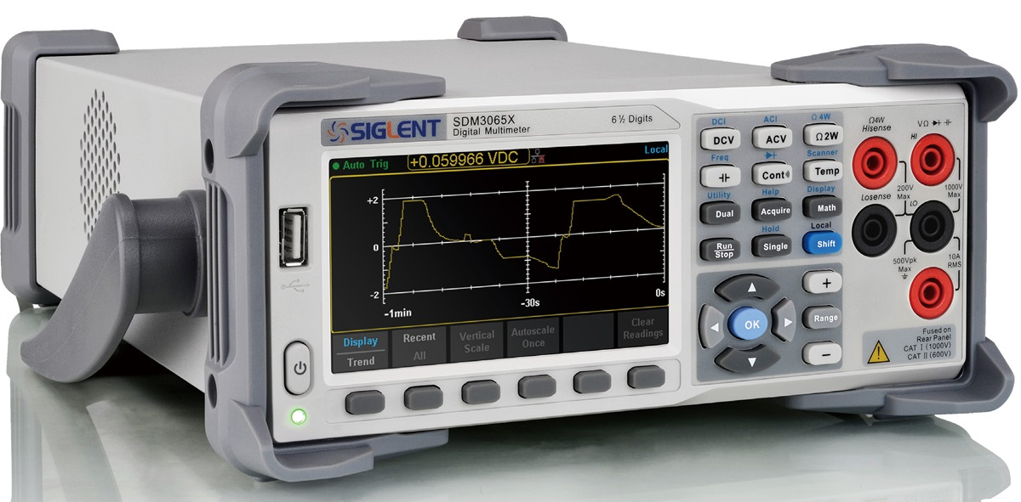
Figure 3: Siglent SDM 3065X (ML03532)
- Measurement Functions:
  - DC Voltage: 200 mV - 1000 V
  - DC Current: 200 μA - 10 A
  - AC Voltage: True-RMS, 200 mV - 750 V
  - AC Current: True-RMS, 200 μA - 10 A
  - 2/4-Wire Resistance: 200Ω - 100 MΩ
  - Capacitance: 2 nF - 100 mF
  - Continuity Test: Range is fixed @2 kΩ
  - Diode Test: Adjustable range is 0 - 4V.
  - Frequency Measurement: 3 Hz - 1 MHz
  - Period Measurement: 1 μs - 333.33 ms
  - Temperature: Support for TC and RTD sensors
- Remote control
- Data logging
  - Logic Analyzer
Description:
Type: Saleae Logic Pro 16
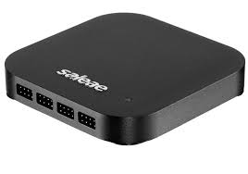
Figure 4: Saleae Logic Pro 16
Features:
- capture, visualize, and search signals
- decode protocols
  - Serial, SPI, I2C, Atmel SWI, Biss-C, CAN, DMX-512, HD44780, HDLC, I2S, JTAG, LIN, MDIO, MIDI, Manchester, Modbus, 1-Wire, PS/2 Keyboard & Mouse, SMBus, SWD, Synchronous Parallel, USB, UNI/O and more
  - Sixteen digital inputs, sixteen analog inputs (shared with digital channels)
- Sample rates:
  - Digital: 500 MSPS @ 4 channels, 100 MSPS @ 16 channels (USB 3.0 required)
  - Analog: 50 MSPS @ 3 channels, 12.5 MSPS @ 13 channels, 6.25 MSPS @ 16 channel
- Supported digital IO standards:
  - 1.2V, 1.8V, 2.5V, 3.3V, 5.0V, RS-232, +12V TTL
  - Automotive Ethernet Switch
Description:
Type: Enhanced Ethernet Switch MACsec H-MTD (TE-2004)

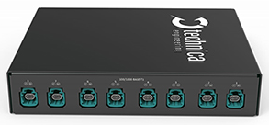  Figure 5: Enhanced Ethernet Switch MACsec H-MTD (TE-2004) Backside | 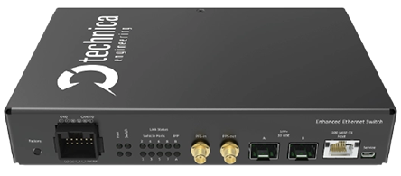  Figure 6: Enhanced Ethernet Switch MACsec H-MTD (TE-2004) Frontside
Interfaces:
- 8x 100/1000BASE-T1 H-MTD
- 2x SFP+
- 2x PPS (In/Out)
- 1x 100BASE-TX (Host Port)
- 1x Service Port
- 2x Wake-Up Line
Features:
- Port Segmentation
- Single / Double VLAN Mode
- Mirroring
- ARP Table
- Single Partition Time Synchronization
- Advanced Filter
- Remote API
- Multi Partition Time Synchronization
- PTPv2 to gPTP Bridge
- Traffic Shaping
- Ingress Rate Limiter
- MACsec + MKA
  - Automotive Ethernet Converter
Description:
Type: Enhanced Ethernet Switch MACsec H-MTD (TE-2004)

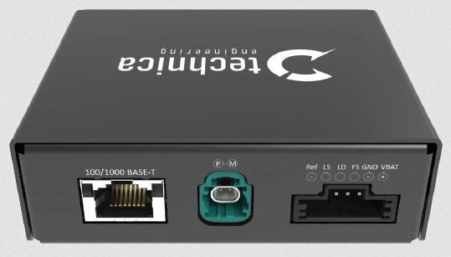  Figure 7: MediaConverter 100/1000BASE-T1 H-MTD TC10 (TE-1406) Front side | 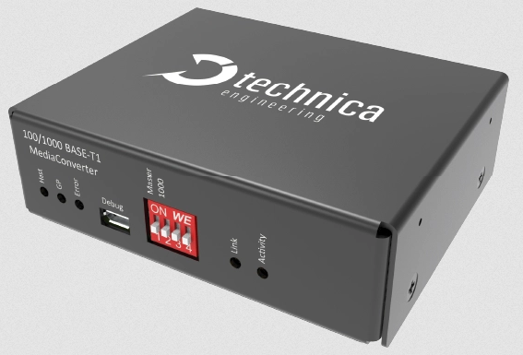  Figure 8: MediaConverter 100/1000BASE-T1 H-MTD TC10 (TE-1406) Back side
Interfaces:
- 1x 100BASE-T1/1000BASE-T1 H-MTD
- 1x 100BASE-TX/1000BASE-T (RJ45)
- Micro USB-B
Features:
- Open Alliance TC10 (Wake/Sleep)
- Frame generator
- Auto Search feature
- Status LEDs and diagnostics
- IEEE test modes
  - Temperature testing chamber
Description:
Vötsch VT7004 temperature test chamber
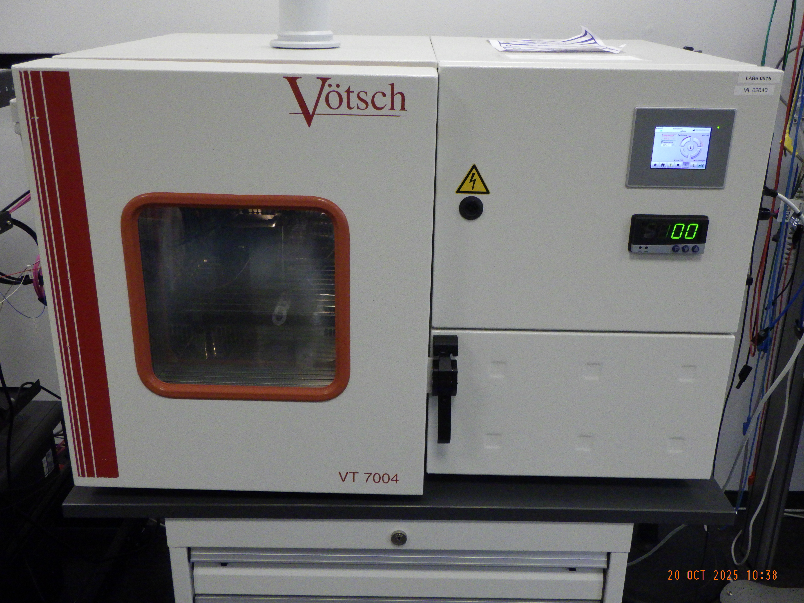
Figure 9: Vötsch VT 7004 temperature test chamber
Features:
- Temperature Range: -70°C to 180°C
- Volume: 37l
- Temperature deviation in time: ±0.2K to ±0.5K
- Temperature rate of change Heating: 5.3 K/min
- Temperature rate of change Cooling: 4.7 K/min
  - Flash programmer
Description:
  - HIL-PC
Description: Lenovo ThinkStation P7
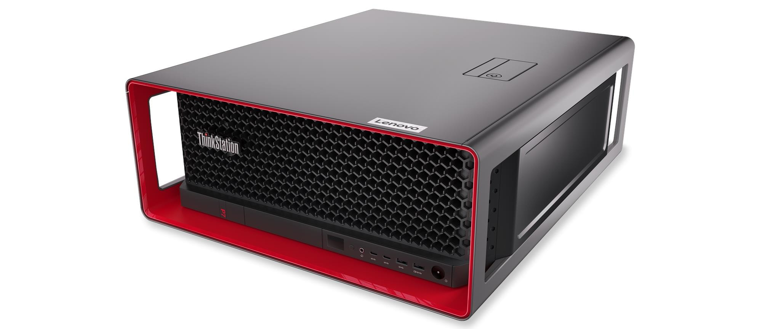
Figure 10: Lenovo ThinkStation P7
Specification:
- Intel® Xenon® W5 3435X
- 64Gbyte RAM
- 2TB SSD
- NVIDIA RTX 4500Ada

  - Test Environment Software

To implement the test cases, the company ISYST’s test framework (Python) is used. By integrating various libraries and APIs into the framework, a wide range of different devices and software tools can be utilized. The test execution is managed via the software “iTest Studio TA”.
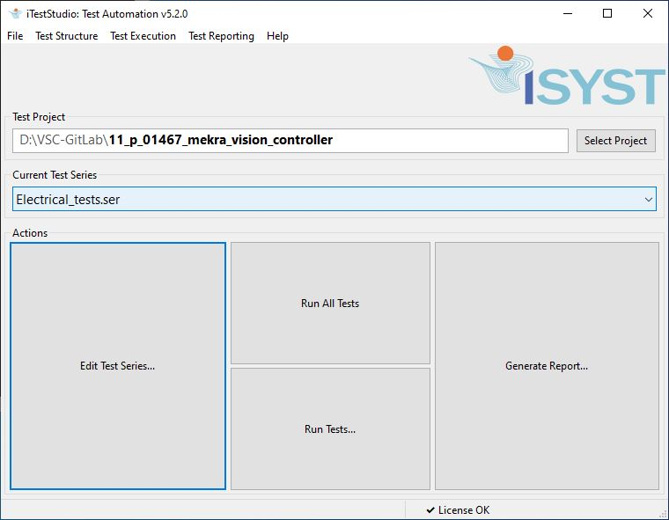
Figure 11: iTestStudio tool

The HIL test environment uses the following software tools:
Table 4: List of HIL software tools
Tool | Version | Use Case
Python | 3.13.3 | Used to control test equipment for generating and executing automated long time tests with multiple iterations.
Polarion |  | ALM tool for administration of requirements and test cases according to ASPICE.
VSCode | 1.104.2 | Programming environment used for code writing and generating test cases.
TestToolkit | 2.2.1 64bit | The tool is a Python based bibliotheque for test execution, middleware and generation of test reports. The tool is developed and provided by ISYST.
iTestStudio TA | v5.2.0 | Executing tool for test runs, test execution and generating test reports.
Mozilla Firefox | 143.0.4 | Tool for viewing test results generated in html.
Gstreamer | 1.26.3 | Open Source multimedia framework for showing a videostream
PyVISA | 1.15.0 | Python package that enables you to control all kinds of measurement devices independently of the interface (e.g. GPIB, RS232, USB, Ethernet).
NI-VISA | 2025Q2 | The Virtual Instrument Software Architecture (VISA) is a standard for configuring, programming, and troubleshooting instrumentation systems comprising GPIB, VXI, PXI, Serial, Ethernet, and/or USB interfaces. VISA provides the programming interface between the hardware and development environments such as LabVIEW, LabWindows/CVI, and Measurement Studio for Microsoft Visual Studio.
MessagePack | 1.1.1 | Efficient binary serialization format. It lets you exchange data among multiple languages like JSON.
proFrame | sxpf-win64_r8720 | a modular frame grabber system for the capture and playback of video data streams.
WireShark | 4.4.9 | powerful, open-source network protocol analyzer that allows users to capture and interactively browse the traffic running on a computer network, providing deep inspection of hundreds of protocols.
PacketSender | 8.9.1 | open source utility to allow sending and receiving TCP, UDP, and SSL (encrypted TCP) packets as well as HTTP/HTTPS requests and panel generation.
Microsoft Windows | WIN10 22H2 | Operating System
Microsoft Windows | WIN11 24H2 | Operating System
Oracle Virtual Box | 7.1.10 r169112 | general-purpose full virtualization software for x86_64 hardware
opencv-python | 4.11.0.86 | Open source computer vison library
GitLab |  | DevOps platform based on Git. It helps teams manage code, automate testing and deployment, and track project progress.
Logic 2 | 2.4.36 | Software to capture, visualize,measure and decode signals for saleae logicanalyzer and decoder
Python | 3.13.3 | Used to control test equipment for generating and executing automated long time tests with multiple iterations.

- LIST OF FIGURES
Figure 1: Test environment architecture for system test, system integration test and allocation test 6
Figure 2: Rohde & Schwarz NGP 824 (ML03573) 6
Figure 3: Siglent SDM 3065X (ML03532) 7
Figure 4: Saleae Logic Pro 16 8
Figure 5: Enhanced Ethernet Switch MACsec H-MTD (TE-2004) Backside 9
Figure 6: Enhanced Ethernet Switch MACsec H-MTD (TE-2004) Frontside 9
Figure 7: MediaConverter 100/1000BASE-T1 H-MTD TC10 (TE-1406) Front side 10
Figure 8: MediaConverter 100/1000BASE-T1 H-MTD TC10 (TE-1406) Back side 10
Figure 9: Vötsch VT 7004 temperature test chamber 10
Figure 10: Lenovo ThinkStation P7 11
Figure 11: iTestStudio tool 12

LIST OF TABLES
Table 1: Referenced documents 4
Table 2: Glossary 4
Table 3: Test environment items 5
Table 4: List of HIL software tools 12

